nvcxsa

Assignment 6

**Date: 06/05/2023**

1. "Shell File to identify Even or odd number by passing number as variable.
2. awk command to filter data in log files based on date.
3. Create Application Load Balancer and Add 2 EC2's in Target Group and route traffic.

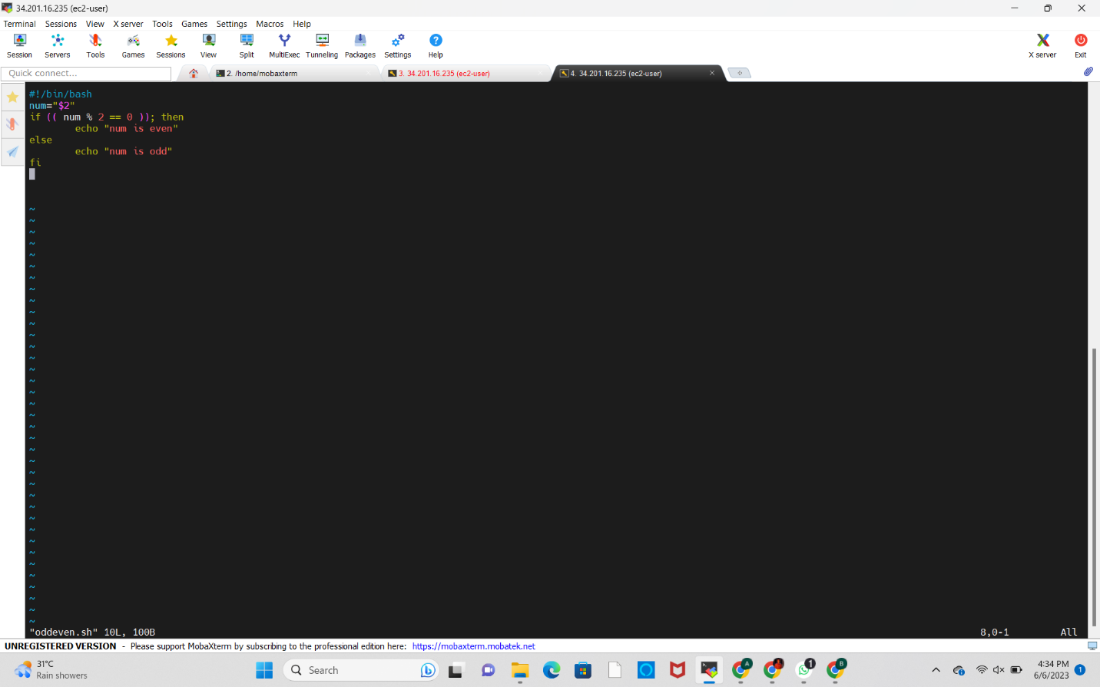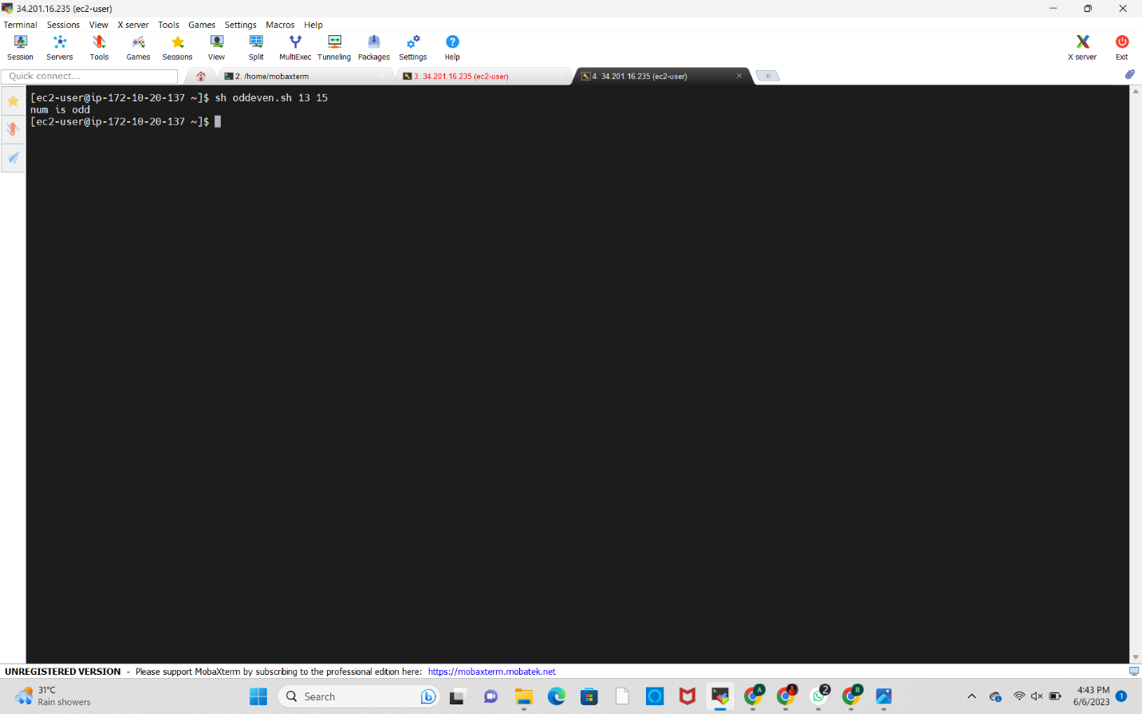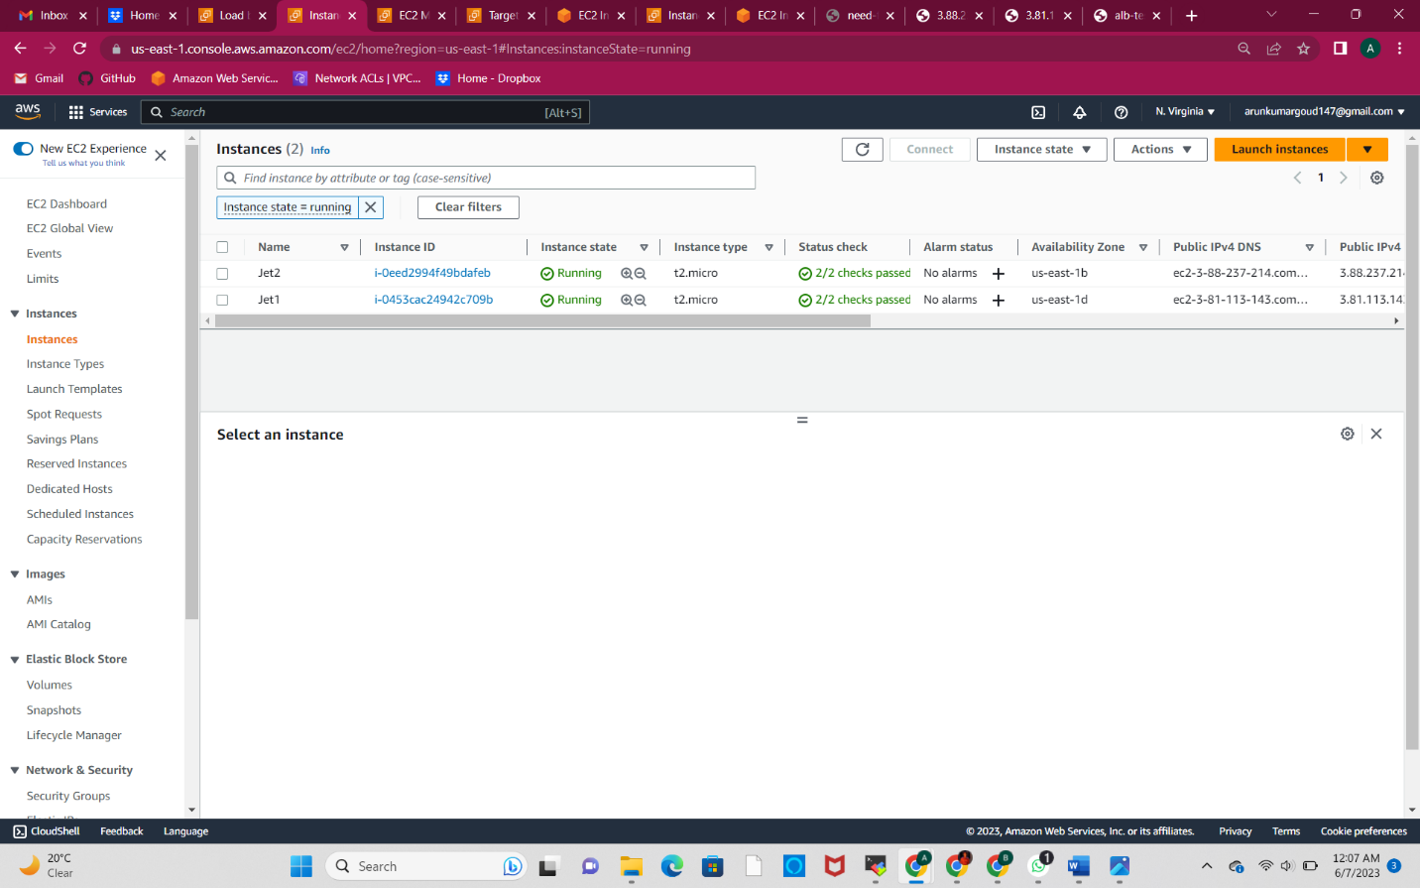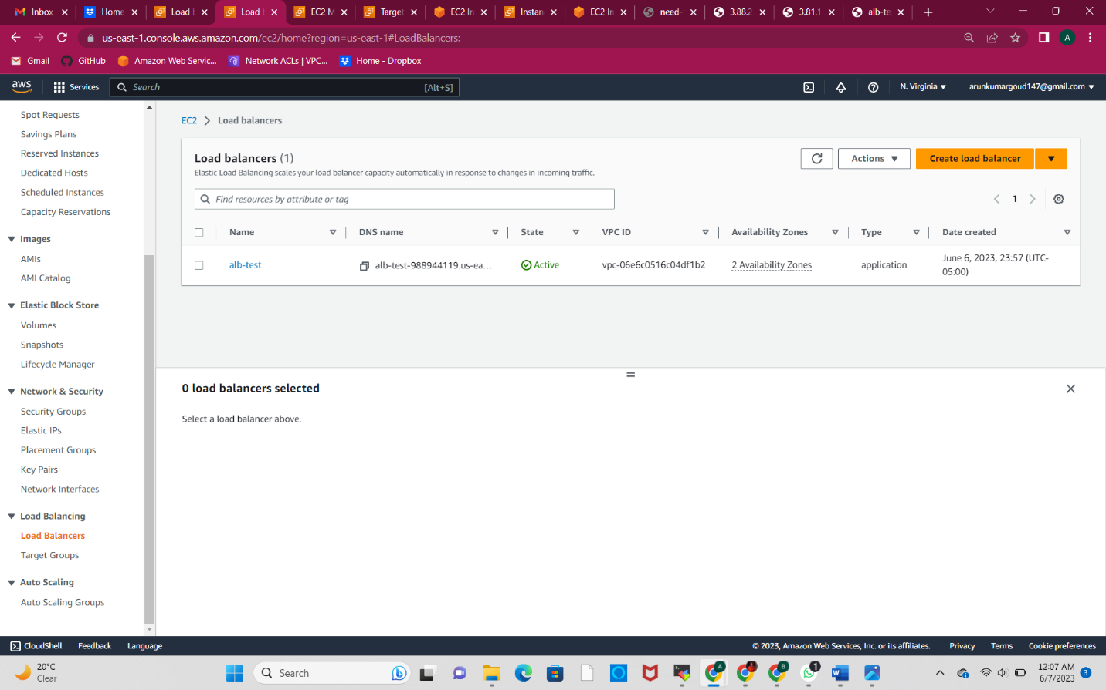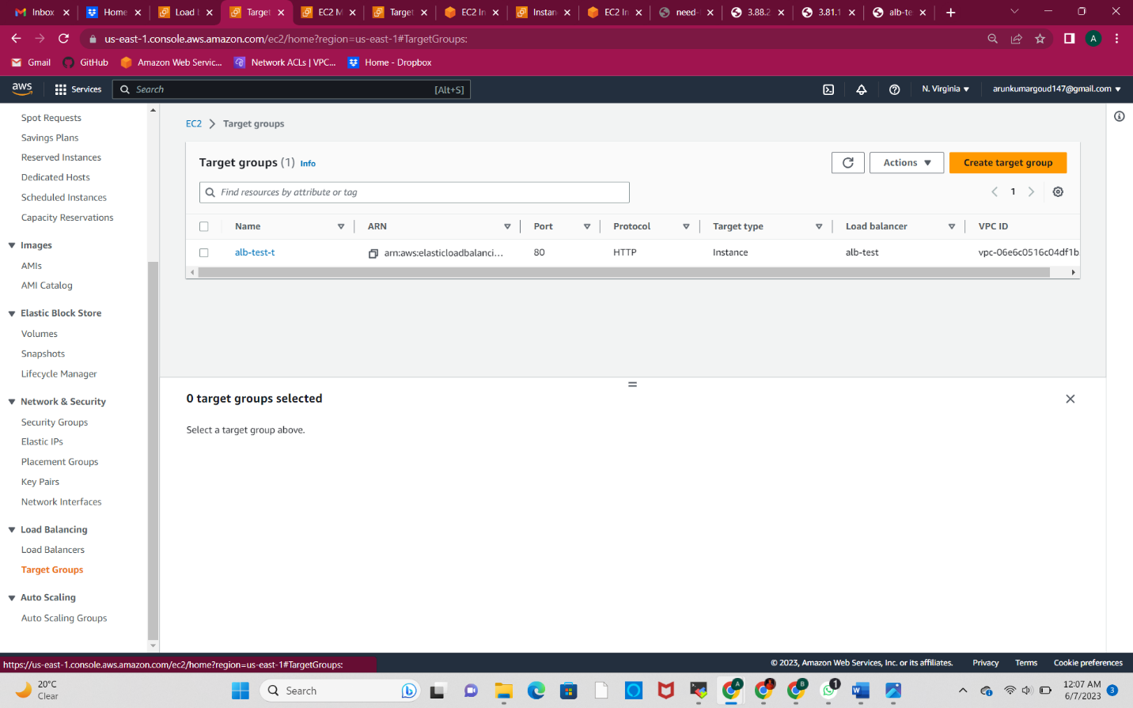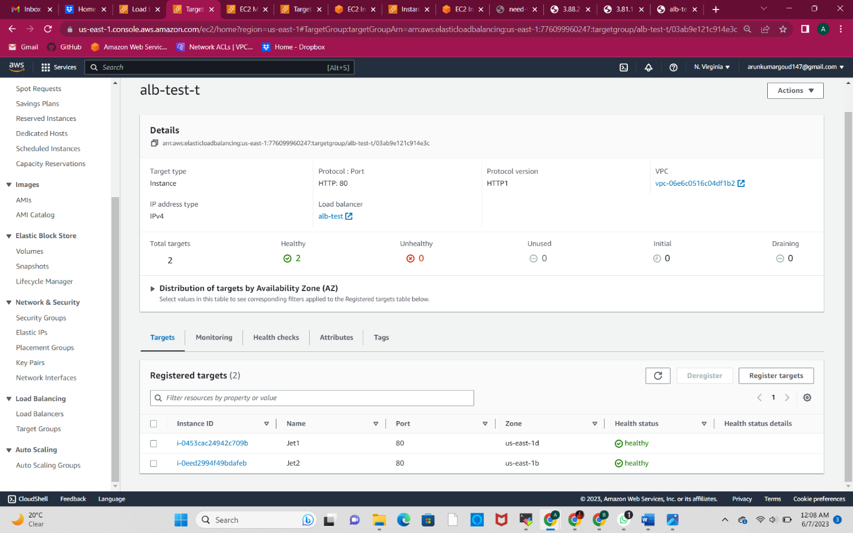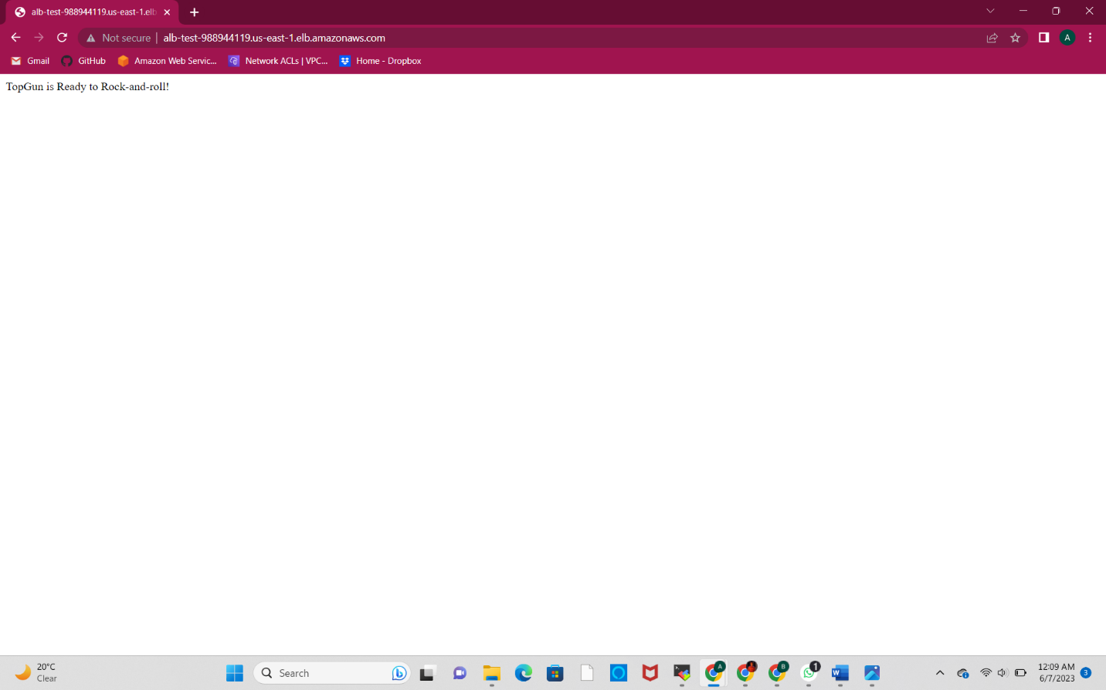

#!/bin/bash

yum update -y

yum install -y httpd

systemctl start httpd

systemctl enable httpd

echo "<h1>TopGun is Ready to Rock and Roll </h1>" > /var/www/html/index.html

